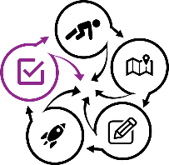

Course title & Number/Section/Term:

Review Worksheet 5.1 and identify changes you can make for this and other courses

Materials, equipment, space, etc.
What can you do to eliminate, minimize the likelihood of occurrence, or mitigate of issues next time?
Eliminate:

Minimize likelihood of occurrence and/or mitigate:

For activities that didn’t go as expected, should you eliminate the activity or change it? If change, what specific changes?

Other problems
What can you do to eliminate, minimize likelihood of occurrence of, or mitigate other problems you faced?
Eliminate:

Minimize likelihood of occurrence and/or mitigate:

Student success
What could students, in general, do better to learn the outcomes and get better grades?

How can you support this?

For outcomes that need more/better support, what activities can you add and/or change?

Recognizing that you may not be able to make all changes for the next offering, which changes CAN you make?

Schedule it
Make a schedule for other changes
Offering #2:

Offering #3:

Offering #4:

What changes might you make in other courses?

Notes

